Python Lab Assignments No.1
- Install python latest version on your machine.

I already installed it before !

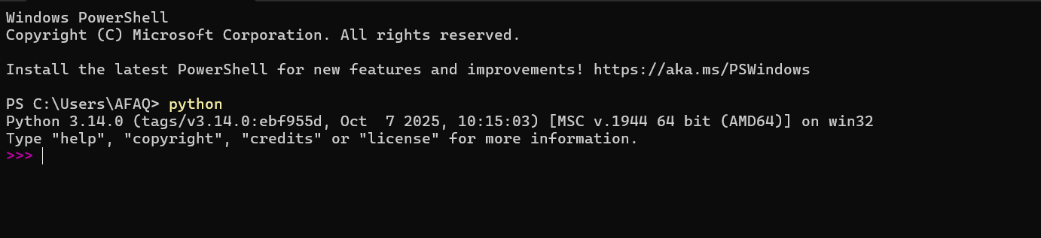

- 🧮 Age
Ask the user to enter their current age and print it.

- # age task
- age = input('Enter your age : ')
- print('your age is',age)

- 🔍 String to Boolean Converter
Ask the user to enter any value.
Cast it to a boolean using bool() and print "Truthy" or "Falsy" based on the

good = bool(input('Enter value :'))
print('your value is :',good)

